**Automatic task scheduler Process**

Now we need to schedule this batch file to run, so Open Task Scheduler and click on the right hand side menu option “**Create Basic Task**”

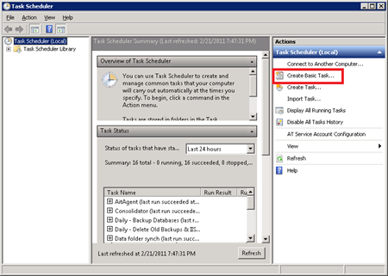

In the new windows, enter a name for your new scheduled task – in the screen grab below I'm calling mine **“IIS Log Cleanup”**and click **Next**

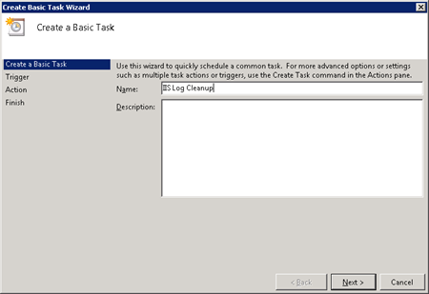

Set the trigger for when to run your task as **Daily** and Click **Next**(this can be set to any schedule you want, however I'm going to run mine every day)

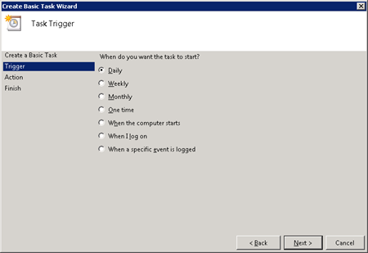

Now enter the time you want this to run this log file clean out every day – I've set mine to 12am. Then Click**Next**

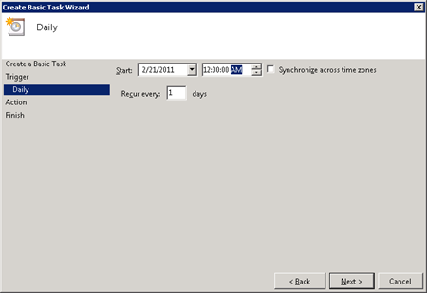

Select “**Start a program**” and click **Next**

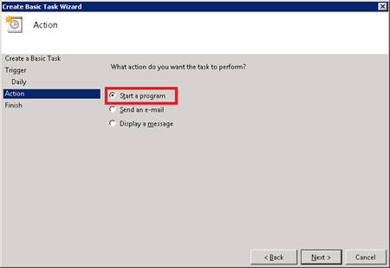

Now click on **Browse** and browse to the BAT file we created above @ **c:\logcleaner\cleanlogs.bat** and when done click **Next**

On the next page, check the box marked “**Open the Properties dialog for this task when i click Finish”**and then click finish

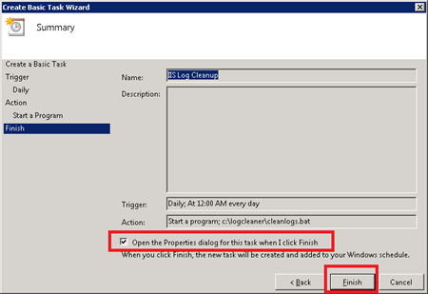

In the new window click on the button marked **Change User or Group** next to the security options area of the dialog. This allows us to specify what user the task will run as.

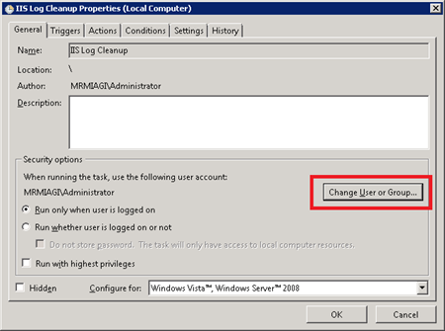

Enter the user **SYSTEM** and click OK

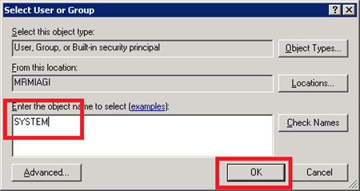

Click **OK**again, and you’re done!

Feel free to run your task manually by right clicking the task and selecting **Run**